Name:___________________________ Date:_________________
Review for Probability Test 7b
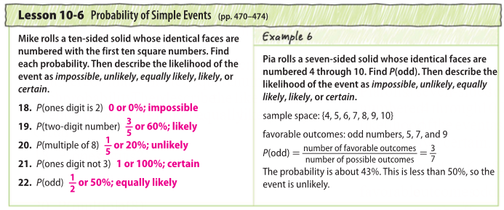

22.5 What is the complement of P(multiple of 8) from #20 above?
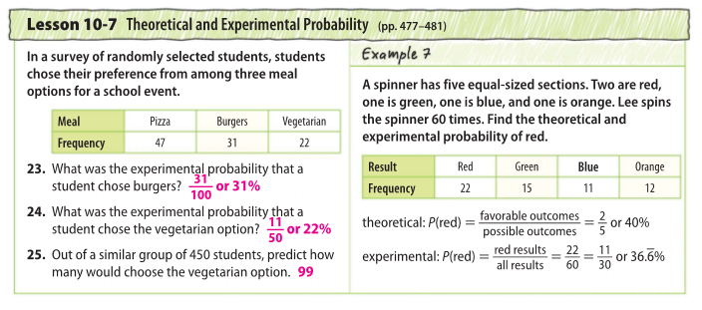

PAGE 1

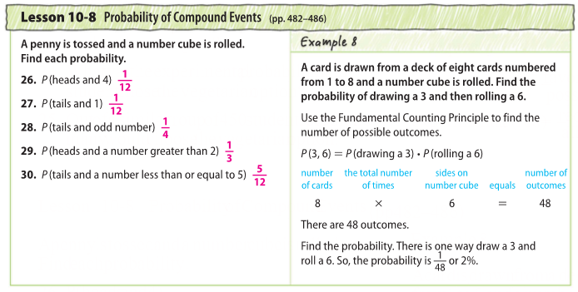

** Remember: Compound Events: find the probability of each event and multiply!
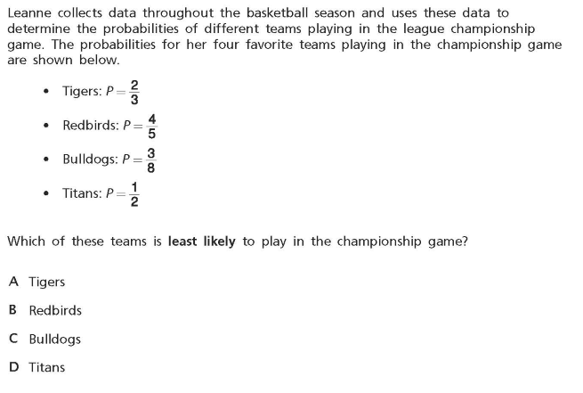
More Practice:

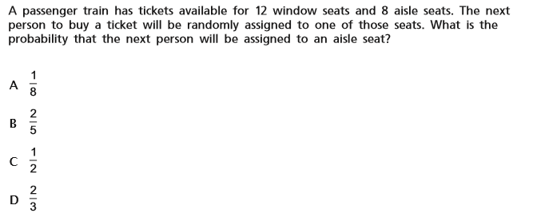

PAGE 2
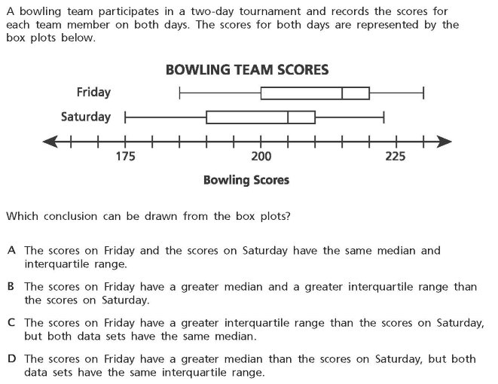

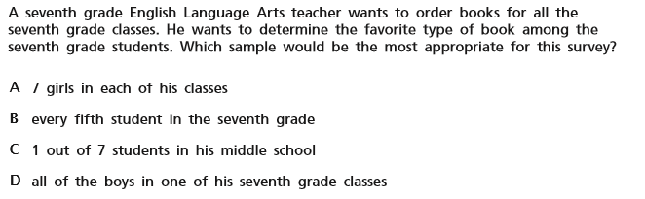
4.

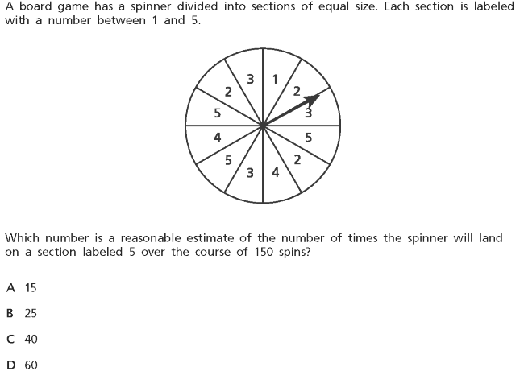
5.

PAGE 3
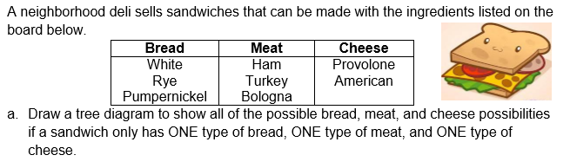
6.

b. P(ham, American) =

c. Probability of ordering a sandwich with white bread, turkey and provolone cheese?

Determine if the following events are independent or dependent. Then find the probability.

7. All of the letters that spell MISSISSIPPI are put into a bag.

What is the probability of selecting a vowel, and then after replacing the letter, also drawing an S?

Dependent or Independent? Probability:

8. Using a standard deck of cards, what is the probability of selecting a red card, without replacement, and then selecting a heart card?

Dependent or Independent? Probability:

9. If you roll a die three times, what is the probability of rolling only even numbers?
Dependent or Independent? Probability: PAGE 4
10. There are 4 black marbles and 2 white marbles in a bag. What is the probability of choosing a black marble, not replacing it, then choosing a white marble?
Dependent or Independent? Probability:

11. How many possible outcomes are there for a locker combination that has a 3 number code?

12. How many possible outcomes are there for a combination that involves the one letter followed by two numbers?

13. a) How many possible outfit options are there if you are choosing between a red, blue and gray shirt, jeans or shorts, and sneakers or flip flops?

b) What is the probability of picking an outfit with a red shirt?

Permutations:
14. There are five finalists in the Mr. Universe pageant. In how many ways may the judges choose a winner and a first runner-up

15. A multiple choice test consists of 15 questions, each with answers (a), (b), (c), (d), and (e). In how many ways could a student fill in the answers if they answer every question?

16. In how many ways could five people line up to get on a bus?

17. How many rearrangements are there of the letters in the word “great?”

18. Evaluate: 4! 19. Evaluate: $\frac{5!}{3!}$ 20. Evaluate: ₆P₃ PAGE 5

21. Create a box plot using the data for the heights in inches of students in middle school.
60 55 54 62 63 61 62 60 61

Five Number Summary:

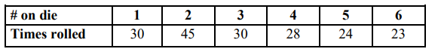
22. Harry rolled the number cube and recorded his results in the table.

- What is the experimental probability of rolling a 2?

- What is the theoretical probability of rolling a 2?

- If Harry were to roll the die 144 times, predict how many times he would land on the number 5, using his experimental probability.

23. Solve for x: 5(x+2) + 3x = 26

24. Is the number $\frac{3}{4}$ rational, irrational, whole and/or counting. List all answers.

PAGE 6

